SCOPE OF DISPUTE THE TRANSACTION
Subject : Refund not provided as per the law of director general of civil aviation rule without my consent they sent me a rescheduled ticket
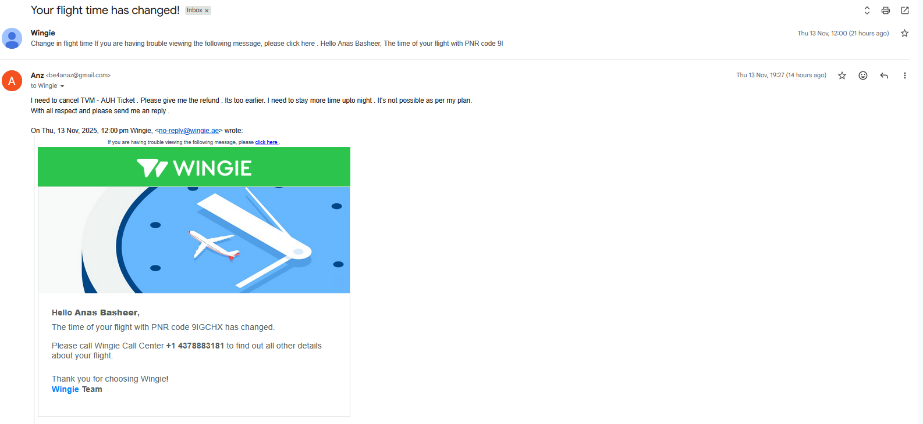
Under DGCA CAR Section 3 – Air Transport Series M, Part IV, the rules state:
“In case of flight cancellation initiated by the airline, passengers shall be offered alternate flight arrangements at no additional cost, subject to availability and passenger consent.”
BUT THEY DID THIS WITHOUT MY CONSENT -This means:
- No extra charges for rebooking on another flight.
- Availability matters: The airline must have seats on an alternate flight.
- Passenger consent is required: You can decline the alternate flight and opt for a refund instead.
Official Source
You can find this clause in the Passenger Charter of Rights by the Ministry of Civil Aviation
Would you like help drafting a formal request to your airline for alternate arrangements or a refund?

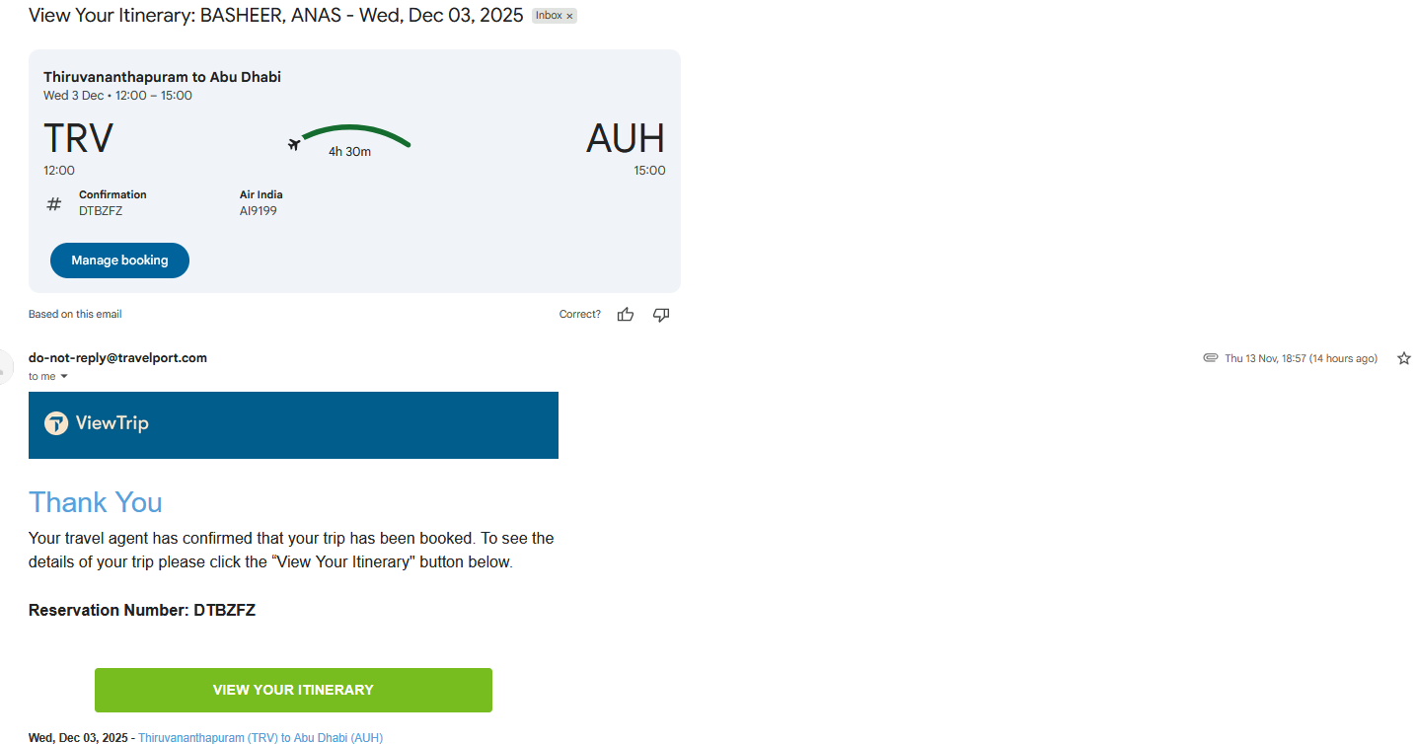

CONCLUSION
HERE THEY DID BOOKING AN ALTERNATIVE FLIGHT WITHOUT MY CONSENT , MY PURPOSE OF VISIT ONLY FULLFILL AT THE END OF THE VISITING TIME AND WORK TO BE DONE.UNLESS ITS WORTHLESS.
SO, I NEED TO DISPUTE THE TRANSACTION OR REFUNDED. NOW I WILL GO FOR DISPUTE THE TRANSACTION.
This is for the Immediate the action of transaction dispute.
Regards,
ENBD ACCOUNT HOLDER
Mr. ANAS BASHEER
IBAN: AE76 0260 0010 1591 5292 601
Account number: 1015915292601
Currency: AED
Swift code: EBILAEAD
Routing number: 302620122

